PostgreSQL Regular Exam - 15 June 2024

Social Media Profiles

You've been chosen to assist renowned social media personalities in managing their online presence. Your expertise in database management will enable you to create and populate a cutting-edge database, ensuring seamless access to information based on specified criteria. Understanding the database structure and populating it with relevant data is paramount for effective information retrieval.

Section 0: Database Overview
You are given an Entity/Relationship Diagram of the Social Media Profiles. This diagram illustrates the connections among different entities within Social Media Profiles, offering a visual depiction of the database structure:
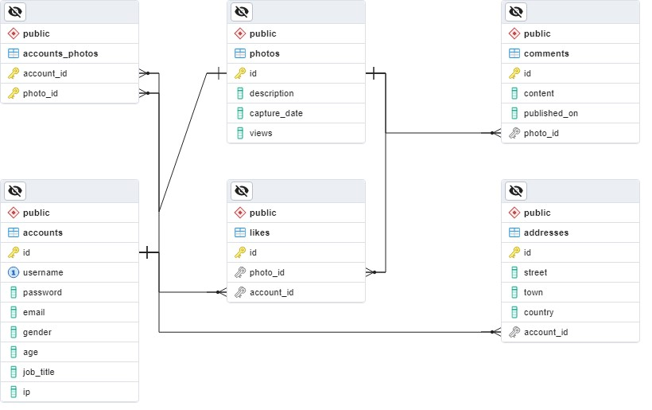
The Social Media Profiles must hold information about accounts, addresses, photos, comments, accounts_photos, and likes.
Your task is to set up a database named sm_profiles (Social Media Profiles) with the following tables:
- accounts – contains information about the accounts.
- addresses – contains information about the addresses.
- photos – contains information about the photos.
- comments – contains information about the comments.
- accounts_photos – a many-to-many mapping table between the accounts and the photos.
- likes – contains information about the likes.

Section 1: Data Definition Language (DDL) - 30 Pts
Make sure you implement the database tables correctly.
Important Note: When working with dates, please adhere strictly to the specified data types in the model tables. For example, if a column is defined as type 'DATE,' ensure that you utilize the 'DATE' data type. Similarly, if a column is designated as 'TIMESTAMP,' use the 'TIMESTAMP' data type. Failure to use the correct data type may result in your submission being rejected by the Judge system.

Table Design
You have been tasked to create the tables in the database by following the specified models.
Submit only your CREATE statements for all tables to the Judge System.

accounts
Column Name | Data Type | Constraints
id | Integer, from 0 to 2,147,483,647 | Primary Key, Unique table identification, Auto-incremented
username | String containing a maximum of 30 characters | NULL is NOT permitted.  UNIQUE values.
password | String containing a maximum of 30 characters | NULL is NOT permitted.
email | String containing a maximum of 50 characters | NULL is NOT permitted.
gender | Exactly 1 character ('M' or 'F' char) | NULL is NOT permitted. The column must contain an 'M' or 'F' char.
age | Integer, from 0 to 2,147,483,647 | NULL is NOT permitted.
job_title | A string containing a maximum of 40 characters | NULL is NOT permitted.
ip | A string containing a maximum of 30 characters | NULL is NOT permitted.

addresses
Column Name | Data Type | Constraints
id | Integer, from 0 to 2,147,483,647 | Primary Key, Unique table identification, Auto-incremented
street | String containing a maximum of 30 characters | NULL is NOT permitted.
town | String containing a maximum of 30 characters | NULL is NOT permitted.
country | String containing a maximum of 30 characters | NULL is NOT permitted.
account_id | Integer, from 0 to 2,147,483,647 | Relationship with table accounts. Cascade Operations. NULL is NOT permitted.

photos
Column Name | Data Type | Constraints
id | Integer, from 0 to 2,147,483,647 | Primary Key, Unique table identification, Auto-incremented
description | A variable unlimited length of text | NULL is permitted.
capture_date | TIMESTAMP, indicates the date and time | NULL is NOT permitted.
views | Integer, from 0 to 2,147,483,647 | The DEFAULT value is 0. The column must always have a value greater than or equal to zero. NULL is NOT permitted.

comments
Column Name | Data Type | Constraints
id | Integer, from 0 to 2,147,483,647 | Primary Key, Unique table identification, Auto-incremented
content | String containing a maximum of 255 characters. | NULL is NOT permitted.
published_on | TIMESTAMP, indicates the date and time | NULL is NOT permitted.
photo_id | Integer, from 0 to 2,147,483,647 | Relationship with table photos. Cascade Operations. NULL is NOT permitted.

accounts_photos
Column Name | Data Type | Constraints
account_id | Integer, from 0 to 2,147,483,647 | Relationship with table accounts. Cascade Operations. NULL is NOT permitted.
photo_id | Integer, from 0 to 2,147,483,647 | Relationship with table photos. Cascade Operations. NULL is NOT permitted.
- | - | Composite Primary Key on both columns (account_id and photo_id)

likes
Column Name | Data Type | Constraints
id | Integer, from 0 to 2,147,483,647 | Primary Key, Unique table identification, Auto-incremented
photo_id | Integer, from 0 to 2,147,483,647 | Relationship with table photos. Cascade Operations. NULL is NOT permitted.
account_id | Integer, from 0 to 2,147,483,647 | Relationship with table accounts. Cascade Operations. NULL is NOT permitted.

Section 2: Data Manipulation Language (DML) - 10 Pts
Before starting, ensure to import the 'dataset.sql' file. Successful insertion of data is contingent upon the proper creation of the database structure.
This section entails executing various data manipulation tasks:

Insert
You need to insert data records into the 'addresses' table, derived from the 'accounts' table.
For accounts identified as female gender, insert corresponding data into the 'addresses' table with the following values:
- street - set it to the username of the account.
- town - set it to the password of the account.
- country - set it to the ip of the account.
- account_id - set it to the age of the account.

Example
id | street | town | country | account_id
… | … | … | … | …
99 | 43 Sommers Street | Komsomolskiy | Russia | 96
100 | 34 Nobel Point | Voloka | Ukraine | 87
101 | hgrigoryov4 | U9aH8s4wFns | 50.162.216.179 | 4
102 | wsline6 | oeu5Gbdg0 | 148.176.123.206 | 21
103 | bvickress7 | uof8US | 60.134.160.216 | 47
… | … | … | … | …

Update
Rename those countries from table 'addresses', which meet the following conditions:
- If the country name starts with 'B' - change it to 'Blocked'.
- If the country name starts with 'T' - change it to 'Test'.
- If the country name starts with 'P' - change it to 'In Progress'.

Example
id | street | town | country | account_id
… | … | … | … | …
52 | 98 North Way | Boise | United States | 63
53 | 139 Canary Crossing | Pak Phanang | Test | 84
54 | 1737 Cody Plaza | Qijing | China | 70
55 | 6 Ramsey Place | Rawa Mazowiecka | In Progress | 48
56 | 27400 Di Loreto Terrace | Marechal Deodoro | Blocked | 79
… | … | … | … | …

Delete
As you may recall, during our initial work, data was inserted and updated. Now, there is a need to remove certain addresses from the database.
Delete all addresses from table 'addresses', where the id is divisible by 2 and the street name contains the letter 'r' (case-insensitive).

Example
id | street | town | country | account_id
… | … | … | … | …
51 | 16416 Pierstorff Parkway | Mulyorejo | Indonesia | 45
53 | 139 Canary Crossing | Pak Phanang | Test | 84
54 | 1737 Cody Plaza | Qijing | China | 70
55 | 6 Ramsey Place | Rawa Mazowiecka | In Progress | 48
57 | 7991 Esch Trail | Bartniczka | In Progress | 56
… | … | … | … | …

Section 3: Querying - 40 Pts
Important Note: Now, we'll conduct some data extraction tasks. Please ensure that the database is cleared of any manipulations from the previous operations in the Data Manipulation Language (DML) section. Insert the provided dataset again to maintain consistency with the examples in this section.

Accounts
Extract information about accounts. Select only those whose age is greater than or equal to 18 years and the length of their username is greater than 9 symbols.
Order the results by age descending then by username ascending.

Required Columns
- username
- gender
- age

Example
username | gender | age
chartfordz | M | 100
mcaygill1d | F | 100
gjoannidi3 | M | 98
prestorickx | M | 98
cbaythorp8 | M | 96
… | … | …

Top 3 Most Commented Photos
Extract from the database, the top 3 most commented photos with their count of comments. Exclude those photos that have no description.
Sort the results by comments_count descending, then by photo id in ascending order.

Required Columns
- id as photo_id
- capture_date
- description
- comments_count

Example
photo_id | capture_date | description | comments_count
23 | 2019-10-13 14:13:42 | Duis bibendum, felis sed interdum venenatis, turpis enim blandit … | 4
25 | 2019-07-20 13:08:03 | In congue. Etiam justo. Etiam pretium… | 4
14 | 2020-02-16 13:49:08 | Praesent blandit. Nam nulla. Integer pede justo… | 3
*The description has been shortened for illustrative purposes. You are not supposed to reformat it for this task.

Lucky Accounts
Identify Lucky Accounts where the account id matches their photo id.
Extract the id concatenated with the username (as id_username) and the email for all such lucky accounts.
Sort the results in ascending order by account id.

Required Columns
- id_username (id + " " + username)
- email

Example
id_username | email
12 aroccob | dpendrichb@hhs.gov
… | …

Count Likes and Comments
Retrieve photo IDs along with associated likes count and comments count from the database.
Sort the results by the number of likes in descending order, then by the number of comments in descending order, and finally by photo id in ascending order.

Required Columns
- id as photo_id
- likes_count
- comments_count

Example
photo_id | likes_count | comments_count
1 | 4 | 2
58 | 4 | 1
69 | 4 | 0
… | … | …

Photos Captured on the Tenth Day of the Month
Extract photos from the database only if their capture day is the 10th day of the month.
Summarize their description:
- The summary must be up to 10 symbols long. Append an ellipsis ( "..." ) at the end.
Return the capture date in the format 'DD.MM HH24:MI' as date.
Order the results by capture_date in descending order.

Required Columns
- summary
- date

Example
summary | date
... | 10.12 15:20
Quisque id... | 10.10 08:58
Mauris eni... | 10.05 14:40
… | …

Section 4: Programmability - 20 Pts
Now it's time to showcase your database skills with some dynamic scripting. Get ready to write a series of functions and procedures to demonstrate your versatility.

Get Accounts Photos Count
Create a user-defined function named udf_accounts_photos_count(account_username VARCHAR(30)) that receives an account's username and returns the number of photos the account has uploaded.
Submit only your user-defined function to the Judge system.

Example
Test Query
SELECT udf_accounts_photos_count('ssantryd') AS photos_count;
Result
photos_count
2

Modify Accounts Job Title
Create a stored procedure udp_modify_account with the following parameters:
- address_street
- address_town
The procedure udp_modify_account(address_street VARCHAR(30), address_town VARCHAR(30)) receives a street and a town as inputs and modifies the associated account's job title by appending the string "(Remote) " at the beginning of the current job title if the account exists.
Submit only your stored procedure to the Judge system.

Example
Test Query
CALL udp_modify_account('97 Valley Edge Parkway', 'Nonexistent');
SELECT a.username, a.gender, a.job_title FROM accounts AS a
WHERE a.job_title ILIKE '(Remote)%';
Result
username | gender | job_title

Test Query
CALL udp_modify_account('97 Valley Edge Parkway', 'Divinópolis');
SELECT a.username, a.gender, a.job_title FROM accounts AS a
WHERE a.job_title ILIKE '(Remote)%';
Result
username | gender | job_title
eblagden21 | M | (Remote) Associate Professor

